**Library Management System**

**1. Branch**

CREATE TABLE Branch (

Branch_no INT PRIMARY KEY,

Manager_Id INT,

Branch_address VARCHAR(255),

Contact_no VARCHAR(15)

);

**2. Employee**

CREATE TABLE Employee (

Emp_Id INT PRIMARY KEY,

Emp_name VARCHAR(255),

Position VARCHAR(255),

Salary DECIMAL(10, 2),

Branch_no INT,

FOREIGN KEY (Branch_no) REFERENCES Branch(Branch_no)

);

**3. Books**

CREATE TABLE Books (

ISBN VARCHAR(13) PRIMARY KEY,

Book_title VARCHAR(255),

Category VARCHAR(100),

Rental_Price DECIMAL(10, 2),

Status VARCHAR(3),

Author VARCHAR(255),

Publisher VARCHAR(255)

);

**4. Customer**

CREATE TABLE Customer (

Customer_Id INT PRIMARY KEY,

Customer_name VARCHAR(255),

Customer_address VARCHAR(255),

Reg_date DATE

);

**5. IssueStatus**

CREATE TABLE IssueStatus (

Issue_Id INT PRIMARY KEY,

Issued_cust INT,

Issued_book_name VARCHAR(255),

Issue_date DATE,

Isbn_book VARCHAR(13),

FOREIGN KEY (Issued_cust) REFERENCES Customer(Customer_Id),

FOREIGN KEY (Isbn_book) REFERENCES Books(ISBN)

);

**6. ReturnStatus**

CREATE TABLE ReturnStatus (

Return_Id INT PRIMARY KEY,

Return_cust INT,

Return_book_name VARCHAR(255),

Return_date DATE,

Isbn_book2 VARCHAR(13),

FOREIGN KEY (Return_cust) REFERENCES Customer(Customer_Id),

FOREIGN KEY (Isbn_book2) REFERENCES Books(ISBN)

);

**INSERT QUERY**

**BRANCH**

INSERT INTO Branch (Branch_no, Manager_Id, Branch_address, Contact_no)

VALUES

(101, 1, '123 Main St, City A', '9876543210'),

(102, 2, '456 Elm St, City B', '9876543222'),

(103, 3, '789 Maple St, City C', '9876543233');

**EMPLOYEE**

INSERT INTO Employee (Emp_Id, Emp_name, Position, Salary, Branch_no)

VALUES

(1, 'John Doe', 'Manager', 60000, 101),

(2, 'Jane Smith', 'Manager', 65000, 102),

(3, 'Bob Johnson', 'Manager', 55000, 103),

(4, 'Alice Brown', 'Librarian', 40000, 101),

(5, 'Charlie Davis', 'Assistant Librarian', 35000, 101),

(6, 'Eve Wilson', 'Librarian', 45000, 102),

(7, 'Frank Miller', 'Assistant Librarian', 37000, 102),

(8, 'Grace Lee', 'Librarian', 42000, 103);

**BOOK**

INSERT INTO Books (ISBN, Book_title, Category, Rental_Price, Status, Author, Publisher)

VALUES

('A1234', 'The Great Gatsby', 'Fiction', 20, 'yes', 'F. Scott Fitzgerald', 'Scribner'),

('B2345', 'The Art of War', 'History', 30, 'no', 'Sun Tzu', 'Penguin'),

('C3456', 'Clean Code', 'Technology', 25, 'yes', 'Robert C. Martin', 'Prentice Hall'),

('D4567', 'The History of Rome', 'History', 35, 'yes', 'Livy', 'Oxford'),

('E5678', 'Python Crash Course', 'Technology', 40, 'no', 'Eric Matthes', 'No Starch Press');

**CUSTOMER**

INSERT INTO Customer (Customer_Id, Customer_name, Customer_address, Reg_date)

VALUES

(1, 'Michael Scott', 'Scranton, PA', '2021-12-15'),

(2, 'Pam Beesly', 'Scranton, PA', '2022-01-05'),

(3, 'Jim Halpert', 'Scranton, PA', '2023-05-10'),

(4, 'Dwight Schrute', 'Scranton, PA', '2021-11-22'),

(5, 'Stanley Hudson', 'Scranton, PA', '2023-06-05');

**ISSUESTATUS**

INSERT INTO IssueStatus (Issue_Id, Issued_cust, Issued_book_name, Issue_date, Isbn_book)

VALUES

(1, 1, 'The Great Gatsby', '2023-06-01', 'A1234'),

(2, 3, 'The Art of War', '2023-06-15', 'B2345'),

(3, 5, 'The History of Rome', '2023-06-10', 'D4567');

**RETURNSTATUS**

INSERT INTO ReturnStatus (Return_Id, Return_cust, Return_book_name, Return_date, Isbn_book2)

VALUES

(1, 1, 'The Great Gatsby', '2023-07-01', 'A1234'),

(2, 3, 'The Art of War', '2023-07-20', 'B2345');

**1. Retrieve the book title, category, and rental price of all available books:**

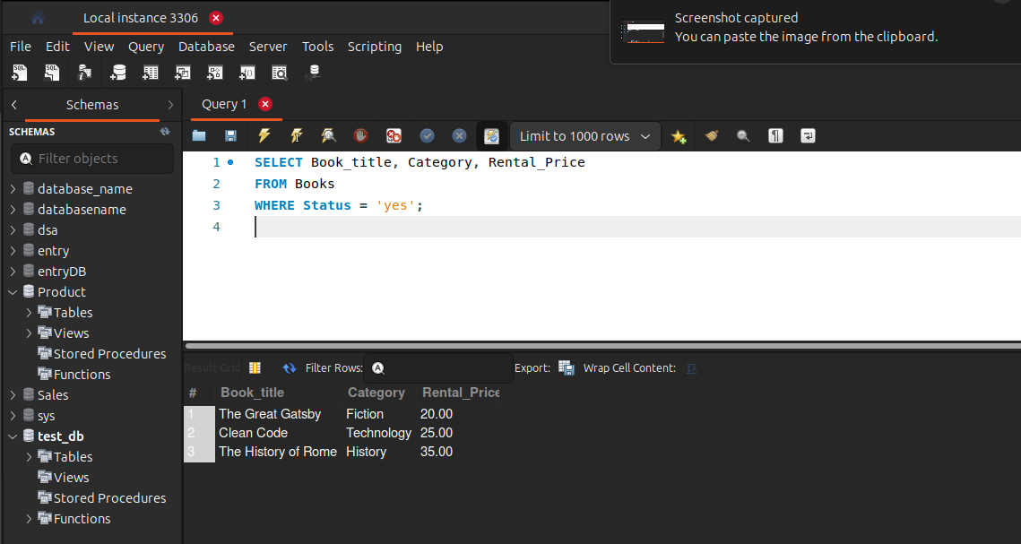

**2. List the employee names and their respective salaries in descending order of salary:**

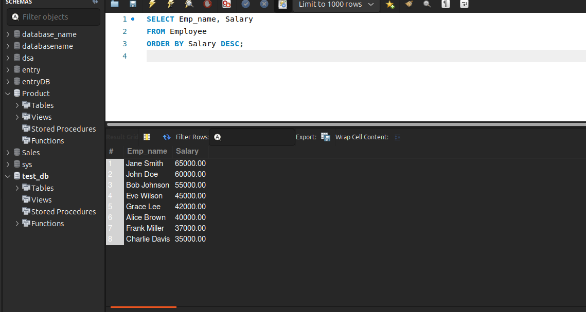

**3. Retrieve the book titles and the corresponding customers who have issued those books:**

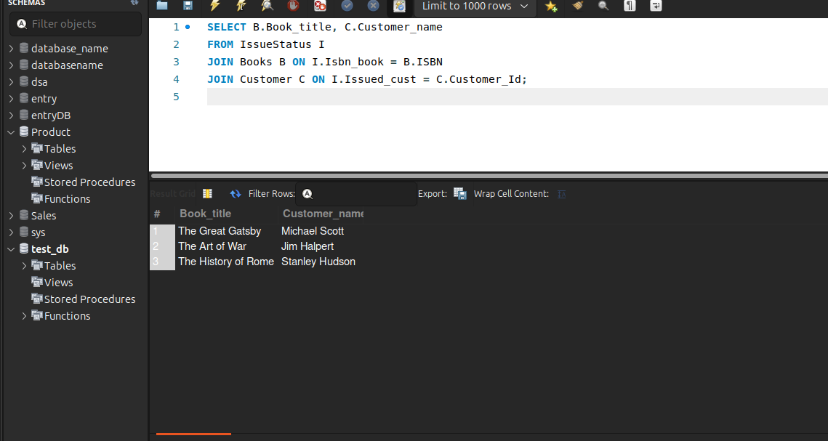

**4. Display the total count of books in each category:**

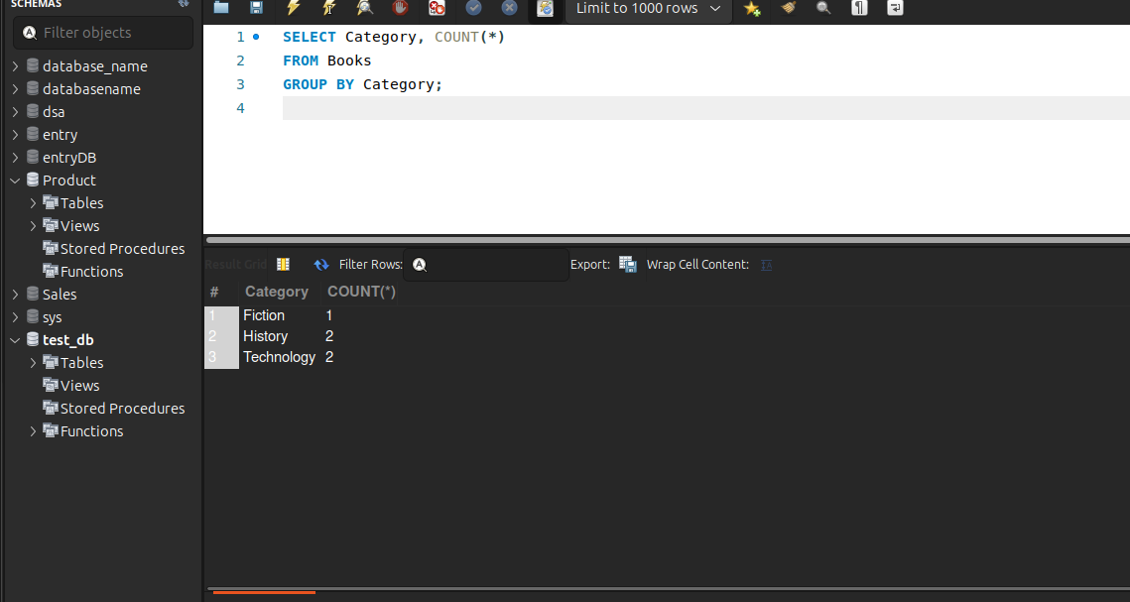

5. Retrieve the employee names and their positions for the employees whose salaries are above Rs.50,000:

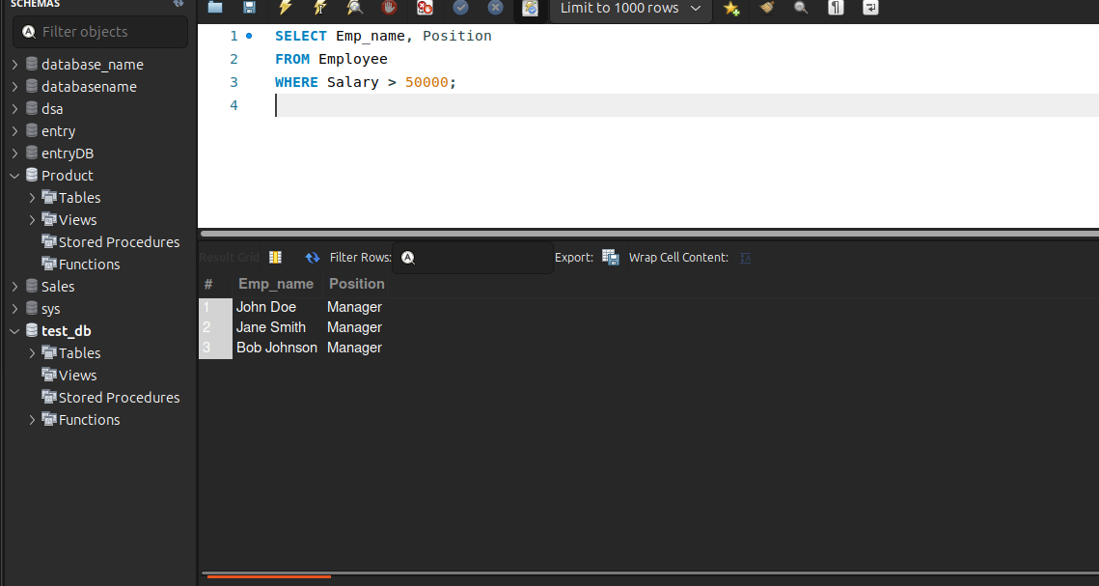

**6. List the customer names who registered before 2022-01-01 and have not issued any books yet:**

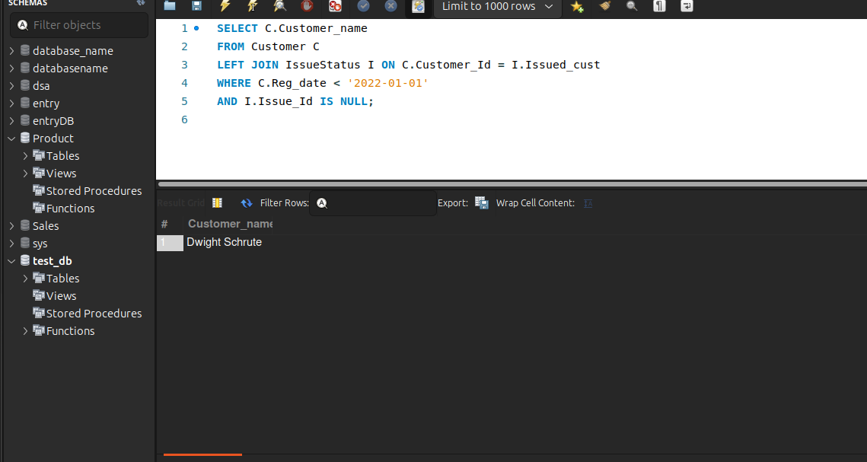

**7. Display the branch numbers and the total count of employees in each branch:**

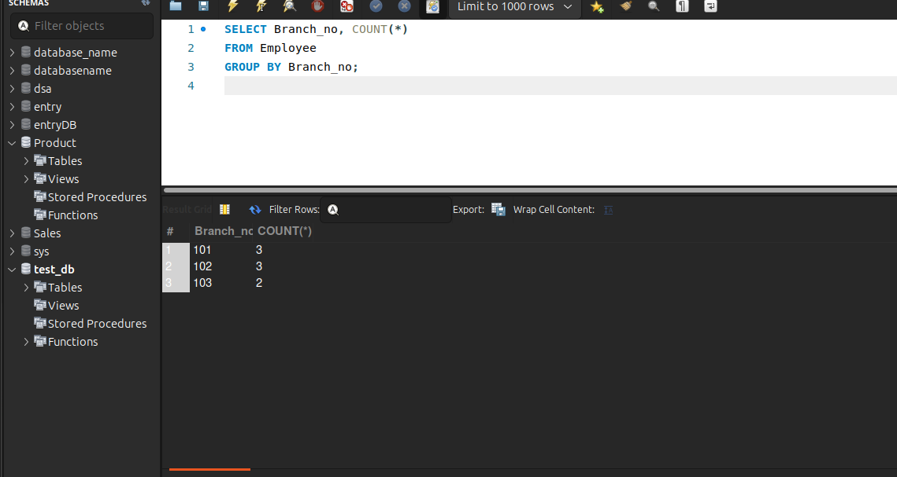

**8. Display the names of customers who have issued books in the month of June 2023:**

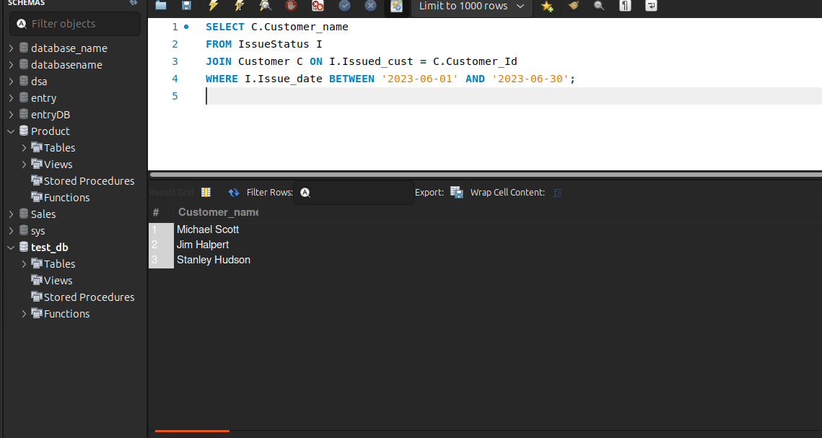

**9. Retrieve book titles from the book table containing 'history':**

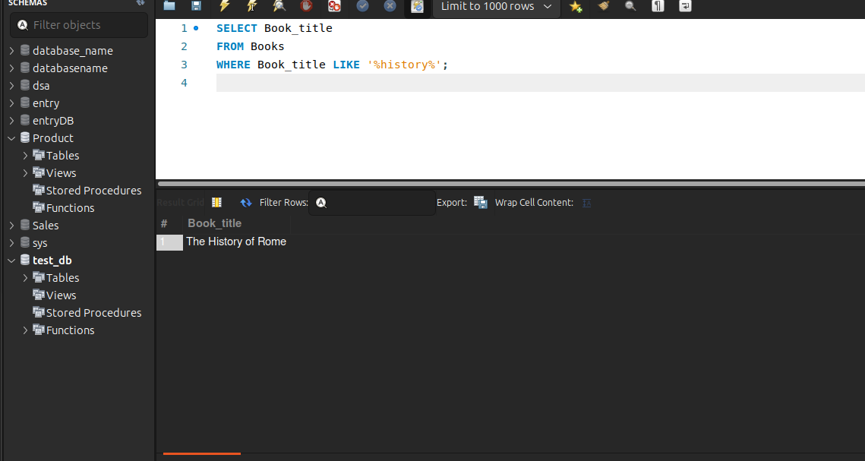

**10. Retrieve the branch numbers along with the count of employees for branches having more than 5 employees:**

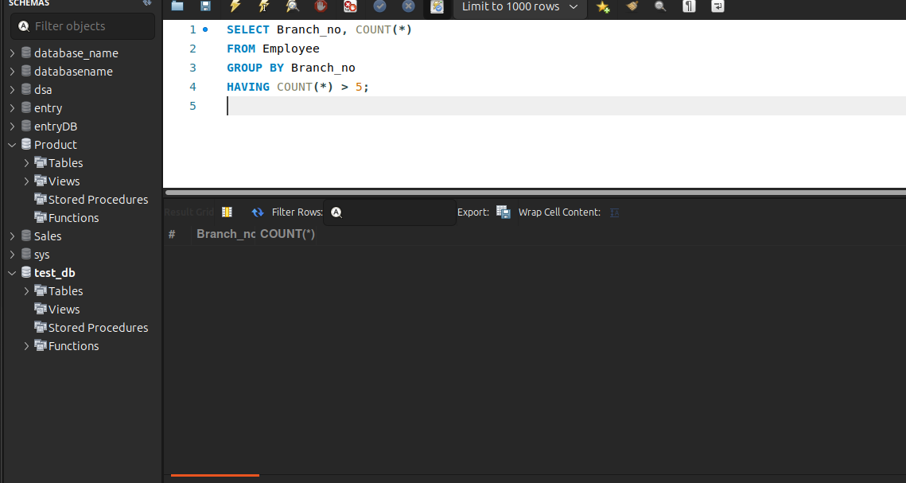

**11. Retrieve the names of employees who manage branches and their respective branch addresses:**

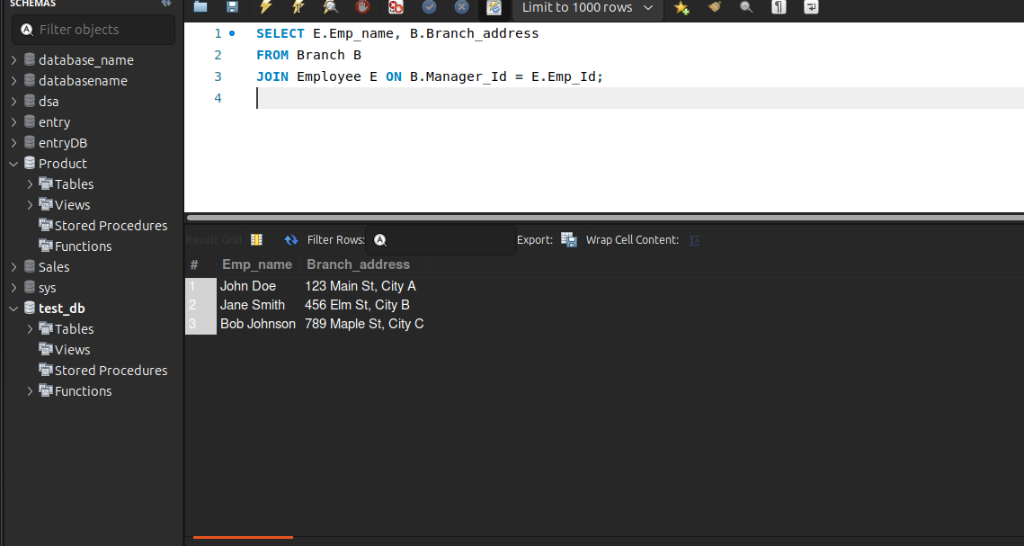

**12. Display the names of customers who have issued books with a rental price higher than Rs. 25:**